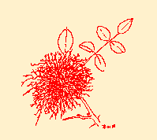
Key to identification of adult insects which may emerge from Diplolepis rosae galls in Britain (drawings by Robin Williams)
b = body; w = wing; ov. = external visible ovipositor sheaths.
Ratios are expressed as %.e.g. w/b 80% means the wings are on average 80% of length of body.
(23) after ‘ratios’ = number of specimens measured, though far more than these may have been recorded but not measured. (2.5-2.9) after ‘size’ = range of sizes found.
Where no description is given, no specimens have been examined. For all that, sufficient information is available for any of these species to be identified with reasonable certainty.
IMPORTANT – body length is given as an average, excluding external ovipositor sheaths. After measuring some 5 or 6 insects, averages tend to remain consistent. The range of sizes may appear extreme but may indicate only one dwarf/giant specimen. Ratios obtained from these measurements form a reliable guide for identification purposes, whereas average lengths are only an indication.
Specific areas illustrated in key are either tinted in drawing or have a line pointing to the feature.

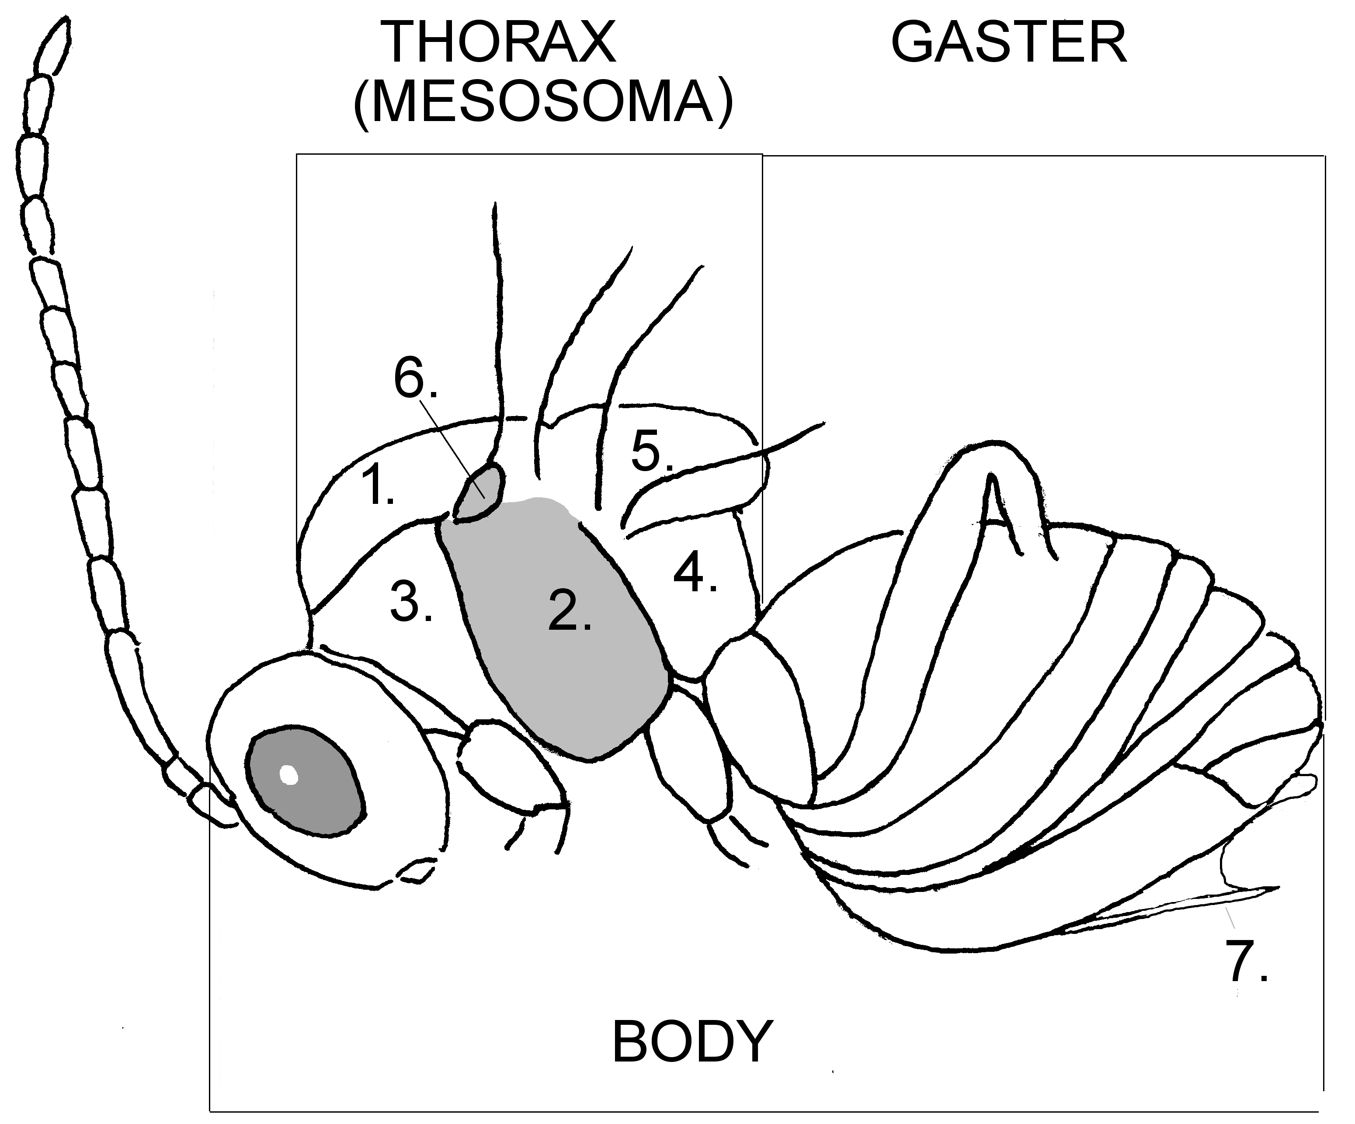
General structure
Legend 1. mesoscutum
(both drawings) 2. mesopleuron (cynipid) or mesepimeron (chalcid)
3. pronotum
4. propodeum
5. scutellum
6. tegula
7. ventral spine, at bottom of hypopygium

Cynipid 
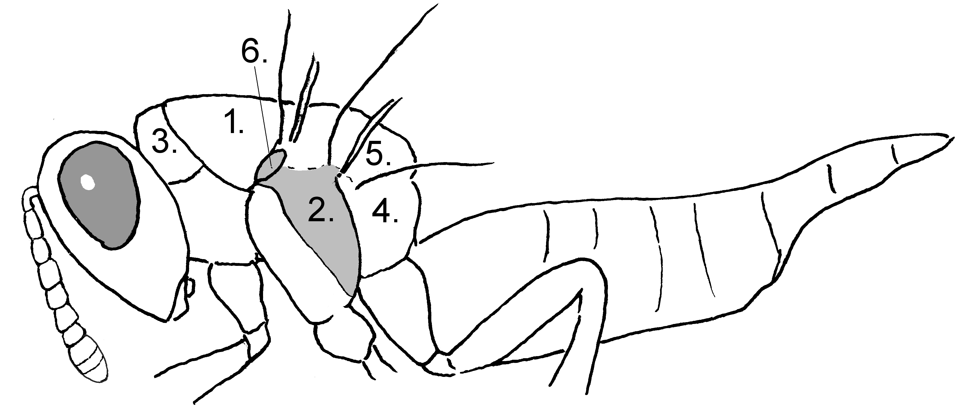

Chalcid (a pteromalid )

1. Forewing with NETWORK of veins 2
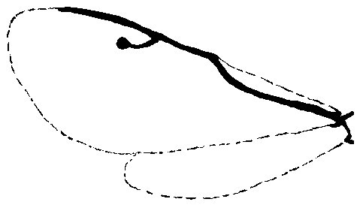 fig 1
• SINGLE main vein along front of forewing (fig1) (Chalcidoidea) 6

2.(1) 14 OR LESS antennal segments (Cynipids) 3
- 20 OR MORE antennal segments (Ichneumon)
Orthopelma mediator (Thunberg) 
 long & slender, with black thorax and head; testaceous gaster with yellow beneath and brown side markings; dark & dirty yellow legs; long, slender, dark antennae; short ovipositor. b. 4.0mm; (2.4-5.0mm), w/b 79%, ov/b 28%; 21 antennal segments (29)*
 long & slender, with black thorax and head; testaceous gaster with yellow beneath and brown side markings; dark & yellow legs; long, slender, dark antennae. b. 4.6mm (2.7-5.5mm), w/b 78%; 20 antennal segments (37)

3.(2) females (): underside of gaster with ventral spine 4
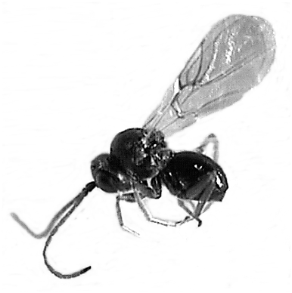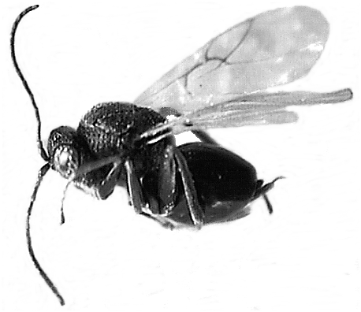
Periclistus brandtii
 
- males (): no ventral spine 5

4.(3) Underside of gaster with conspicuous ‘PLOUGHSHARE’ (ventral spine) (fig 2); gaster mainly BRIGHT chestnut.
Diplolepis rosae (Linnaeus) 
 very dark small head & dark thorax, contrasting with long, swollen bright chestnut & dark gaster with conspicuous ploughshare; pale legs and long black antennae. b 3.8mm (3.0-4.6mm), w/b 95%, 12 antennal segments (28)
fig 2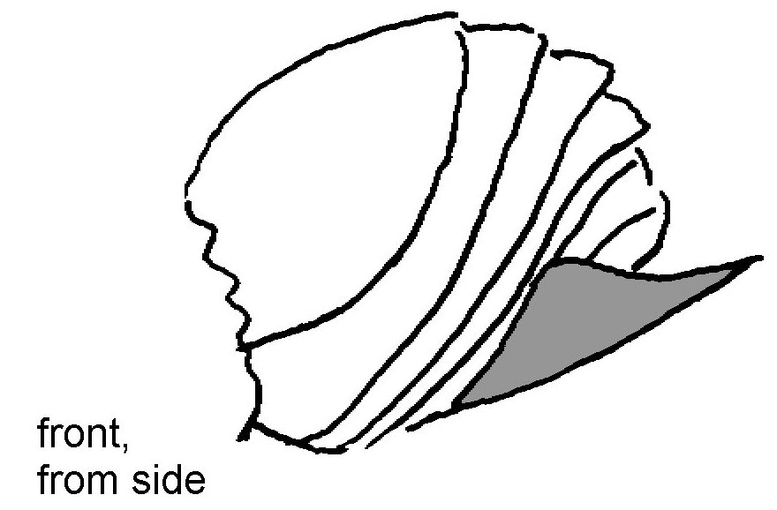 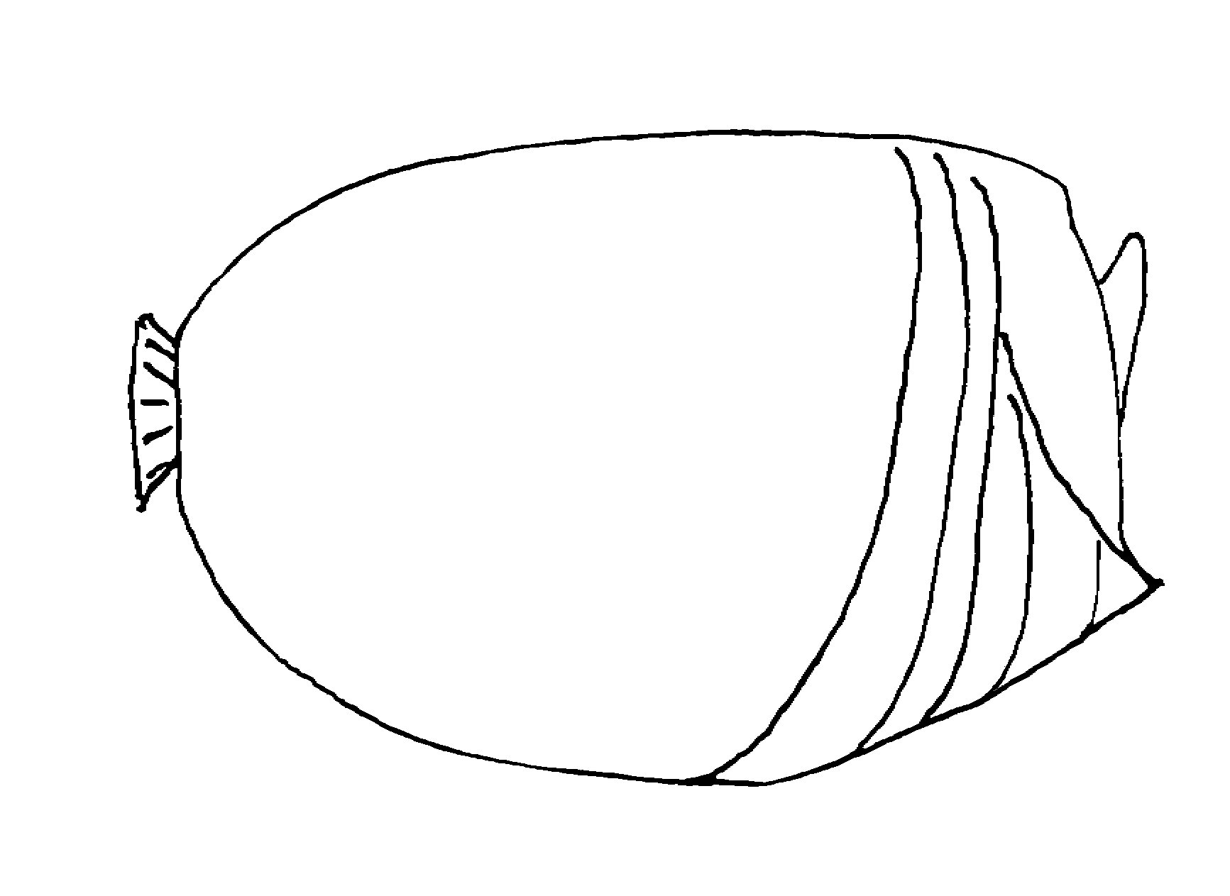fig 3
- Underside of gaster with ‘normal’ ventral spine (not dramatically extended into ‘ploughshare’) (fig 3); gaster DARK.
Periclistus brandtii (Ratzeberg) 
 dark body, with testaceous-gold legs and dark, slender antennae. b 2.7mm (2.4-3.3mm), w/b 107%, 12 antennal segments (24)

5.(3) Third antennal segment LONG & STRAIGHT; antennae DARK; (males are very RARE, perhaps 1% of population).
Diplolepis rosae (Linnaeus) 

 all black body & antennae; bi-coloured yellow legs. b 2.8mm (2.6-3.1), w/b 107%, 14 antennal segments (6)

- Third antennal segment sharply CURVED (fig 4); antennae GOLD.
Periclistus brandtii (Ratzeberg) 
 deep-bodied, with black head & thorax & gaster; testaceous-gold antennae & legs. b 2.1mm (1.8-2.6mm), w/b 119%, 14 antennal segments (24)

fig 4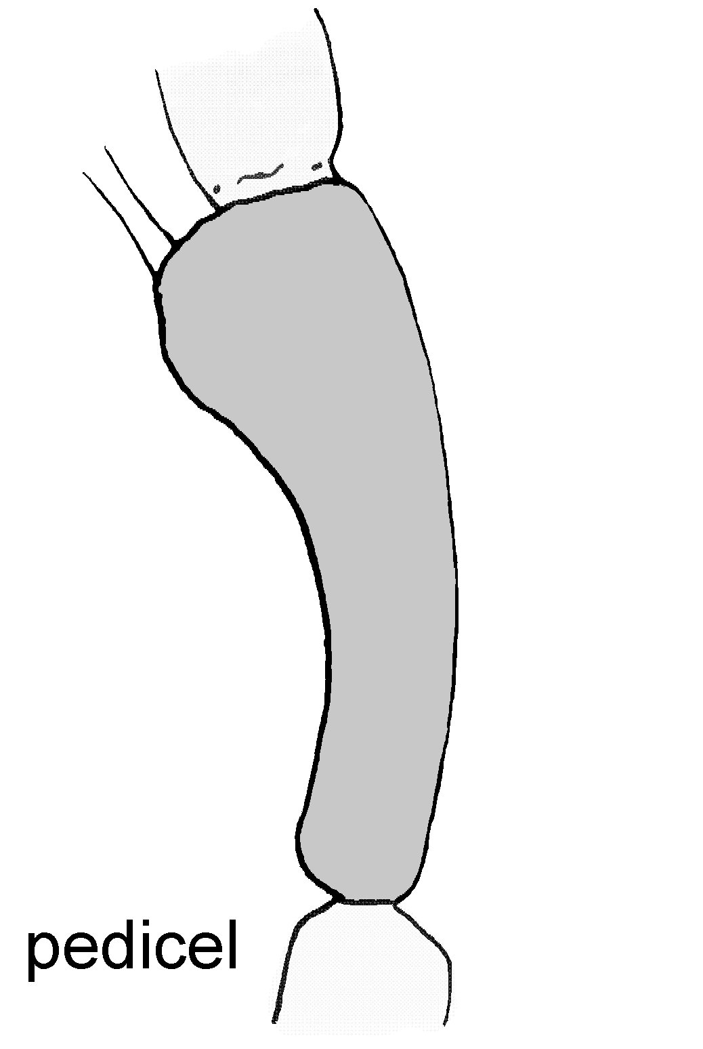

6.(1) Legs with FIVE tarsal segments (fig 5); FIVE or more antennal funicular segments (fig 6) (please note, the club may not be as obvious as this example) 7
fig 5 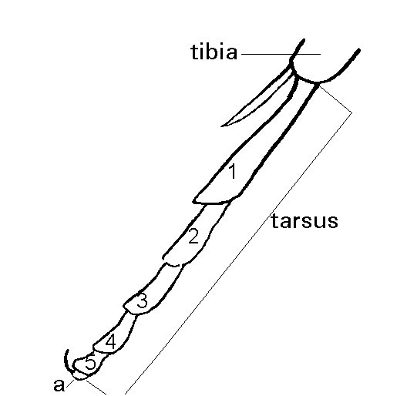 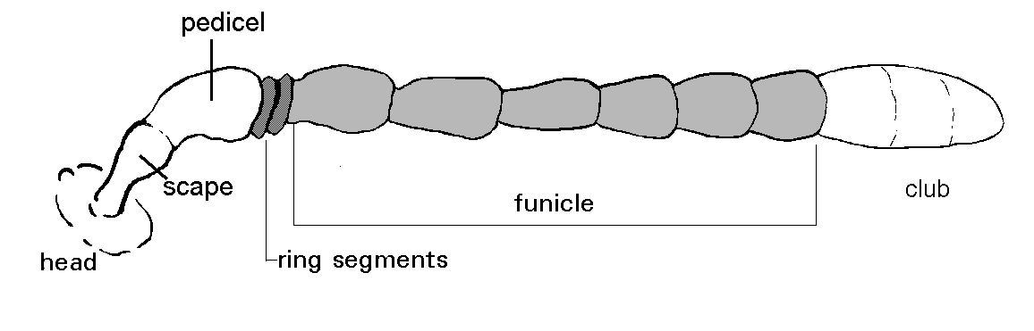 fig 6
- Legs with FOUR tarsal segments (Eulophidae); female antennae with THREE funicular segments, males with FOUR 18

7.(6) Antennal funicle FIVE or SIX-segmented 8
  - Funicle SEVEN-segmented 12

8.(7) Body colour METALLIC green or bronze; pronotum much SHORTER than wide, when viewed from above (fig 7) SIX funicular segments (Pteromalidae) 9
fig 7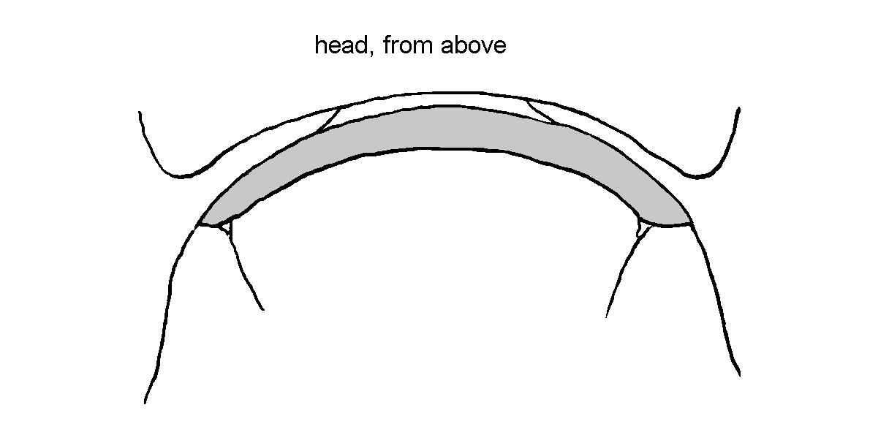 fig 8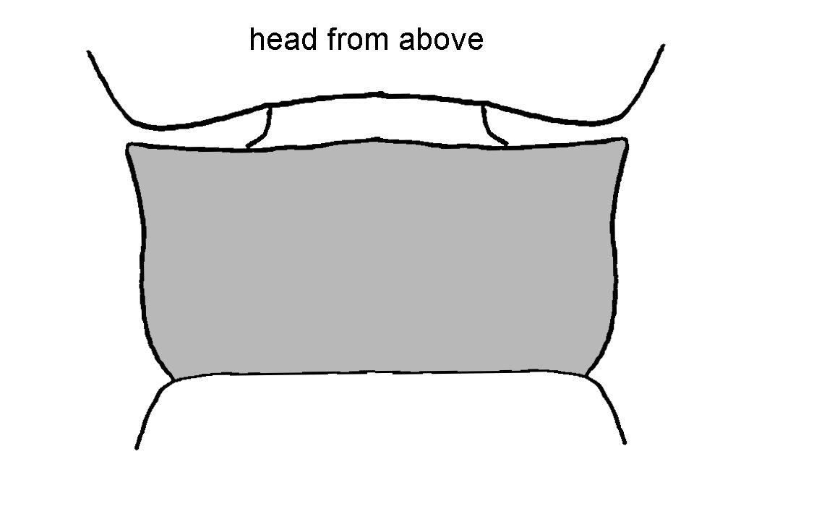
- Body colour black, NON-METALLIC; pronotum more or less rectangular when viewed from above (fig 8); FIVE funicular segments (Eurytomidae).
Eurytoma rosae Nees 
 black & granular, like a Synergus except for venation; black antennae & legs. b 3.2mm (2.4-3.7mm), w/b 77%, ov/b 0%; 5 funicular segments (41)
 black, granular, like a Synergus, petiolate, with short, upright gaster and distinctive knobbly, black antennae with halos of long white hair; dark legs. b 2.1mm (1.4-2.6mm), w/b 86% 5 funicular segments (18)

9.(8) Antennae set towards BOTTOM of eyes (fig 9) (It is essential to have the ocelli in the position indicated); Bright pale yellow legs below metallic coxae; head + thorax BRILLIANT green 10

fig 9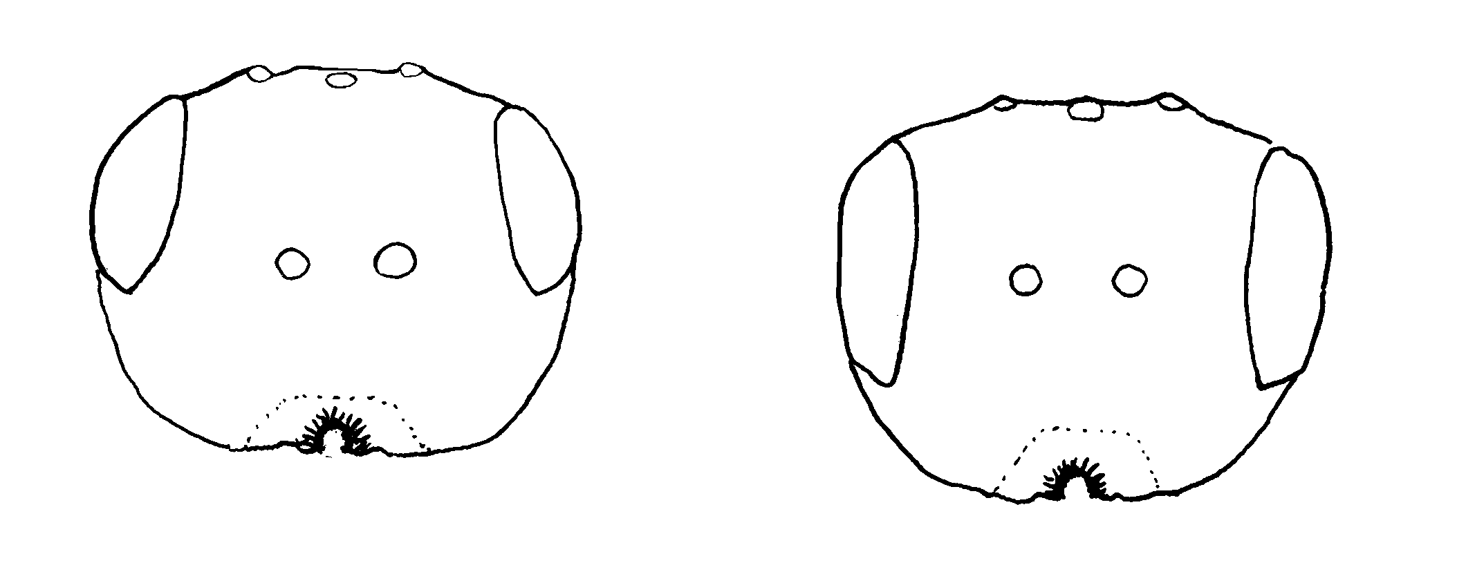fig 10
- Antennae set PART WAY UP eye line (fig 10); head + thorax DARK TO VERY DARK metallic green; legs tapered from dark brown to pale tarsi, giving dirty appearance 11

10.(9) Clypeus with a readily-distinguished INCISION in the middle of lower edge (fig 11); male tibia without projections or markings.
Mesopolobus sericeus (Forster) 
 all metallic green, reticulated; with bright yellow legs and darker yellow antennae; no visible ovipositor. b 3.1mm (2.2-4.0mm), w/b 88%, ov/b 0%; 6 funicular segments (52)
 brilliant metallic blue, bronze, gold and green head & thorax; brown gaster with distinctive yellow shuttle mark above; yellow antennae and pale yellow legs. b 2.1mm (1.4-3.0mm), w/b 97%; 6 funicular segments (49)
fig 11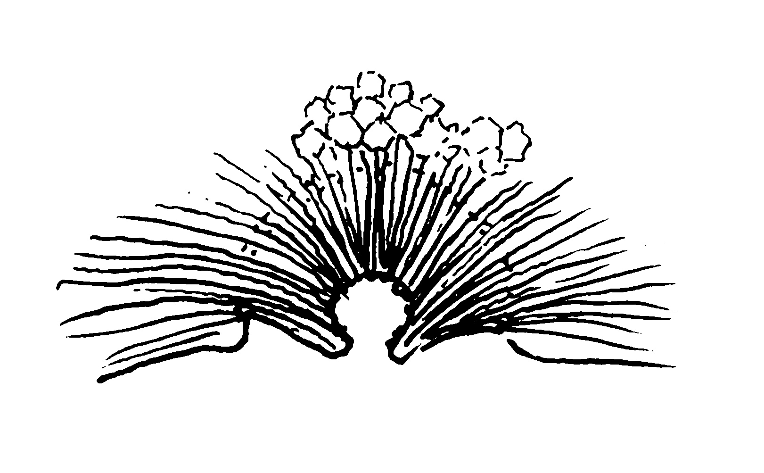 fig 12 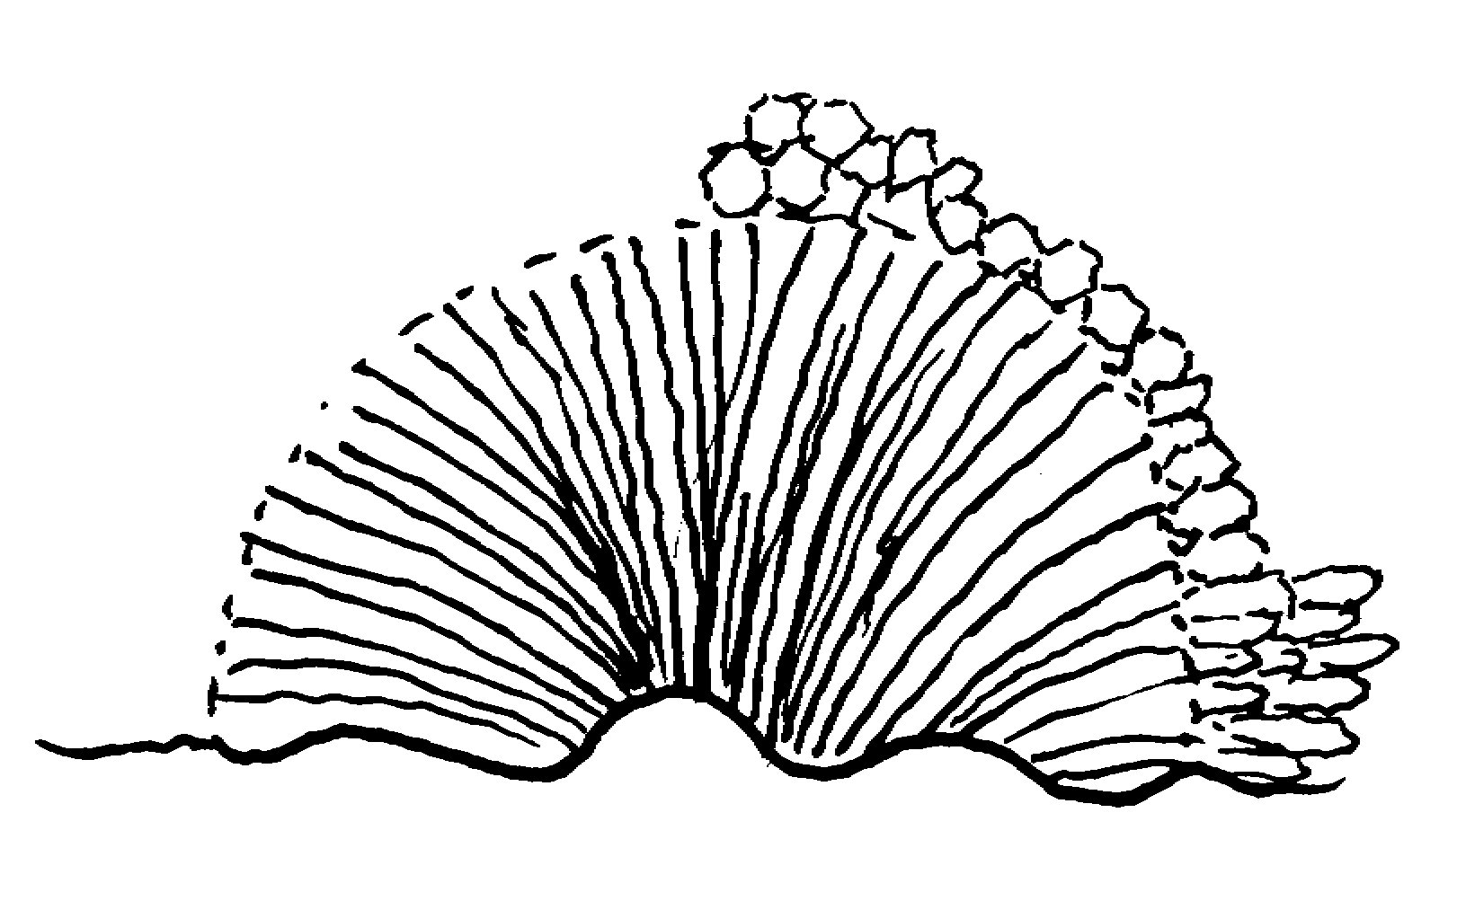 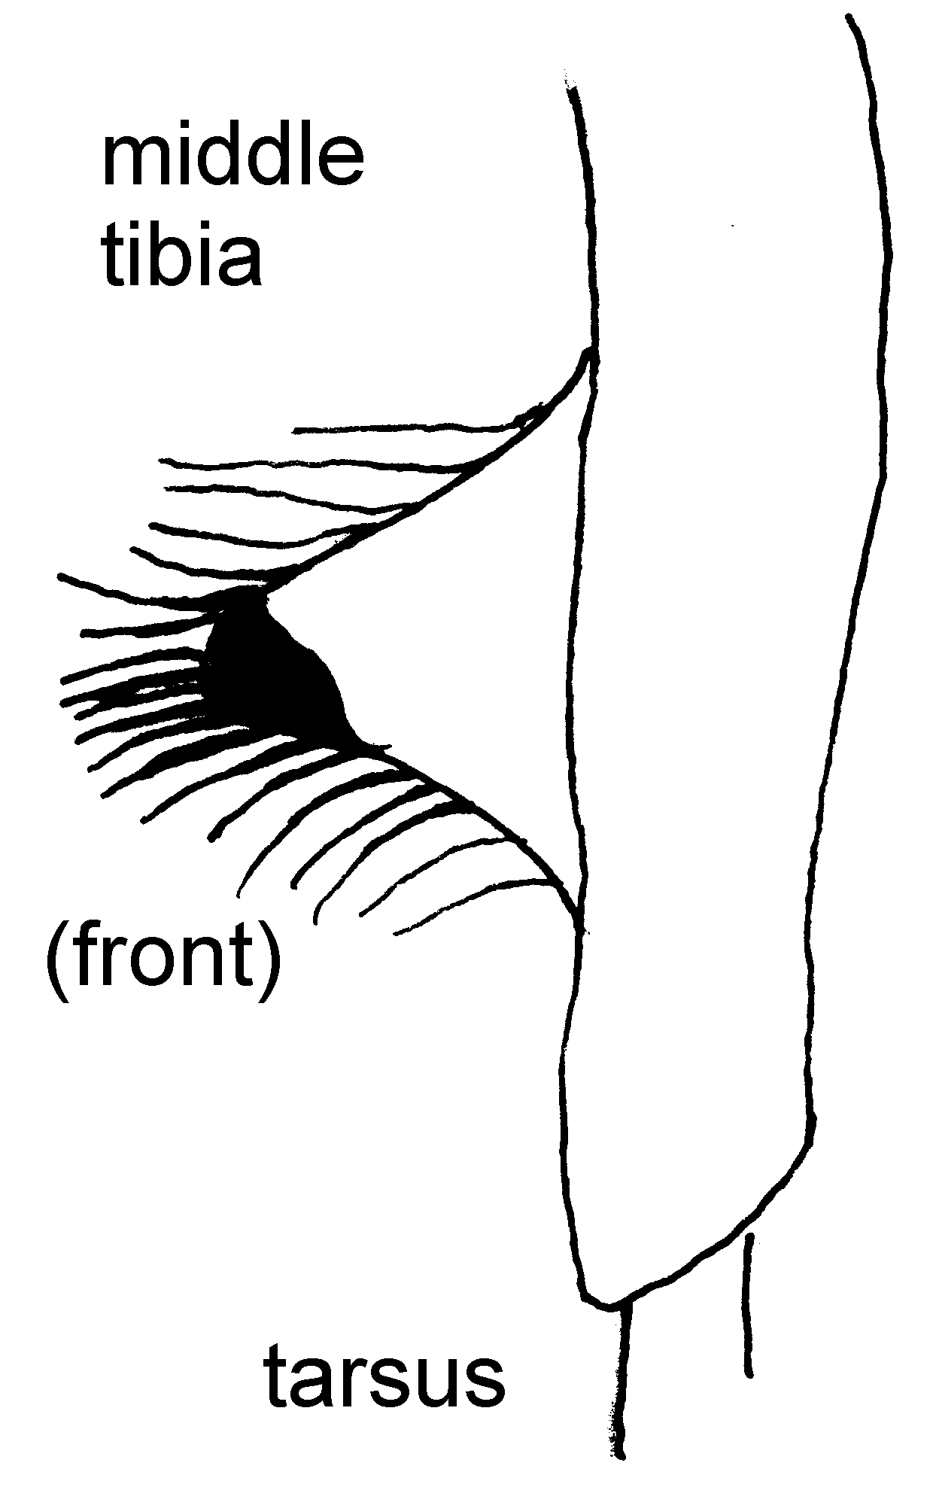fig 13

- Clypeus with WAVED lower edge (fig 12); in the male, a triangular flap, edged with black and a fringe of black hairs (fig 13), lies towards the end of the MIDDLE TIBIA.
Mesopolobus fasciiventris, Westwood 
[note 1]
 brilliant metallic gold-green, green or blue-green body; pale yellow legs; yellow-brown antennae; ovipositor not visible. b 2.6mm (2.2-3.7), w/b 90%, ov/b 0%; 6 funicular segments (9)
 brilliant green head & thorax, with or without gold tints; yellow-banded brown gaster; bright pale yellow legs & antennae. b 1.8mm (1.4-2.4), w/b 94%; 6 funicular segments (11)

11.(9) In both sexes, basal cell of forewing virtually BARE (fig 14) (0-10 or so microtrichia – tiny hairs); WAVED bottom edge of clypeus(fig 16).
Pteromalus bedeguaris (Thomson) 
 black or dark metallic green head & thorax, golden/bronze gaster; neutral bronze, thick antennae; tapering brown legs. b 3.5mm (2.2-4.7mm), w/b 72%, ov/b 0%; 6 funicular segments (35)
 dark blue-green metallic, with bronze tints to head and thorax; dark brown short, wide gaster; brassy-brown antennae and tapering brown legs. b 2.4mm (1.7-3.4mm), w/b 79%; 6 funicular segments (31)

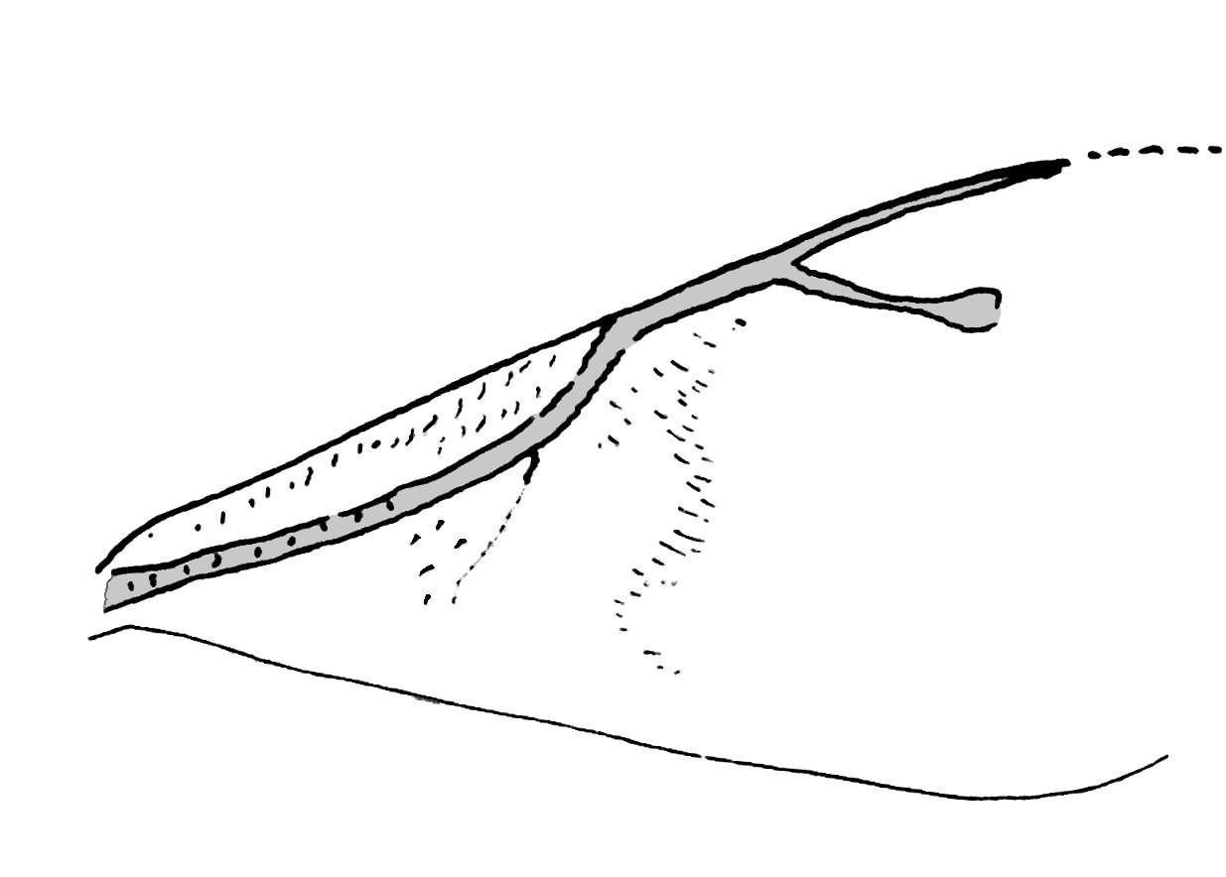 fig 15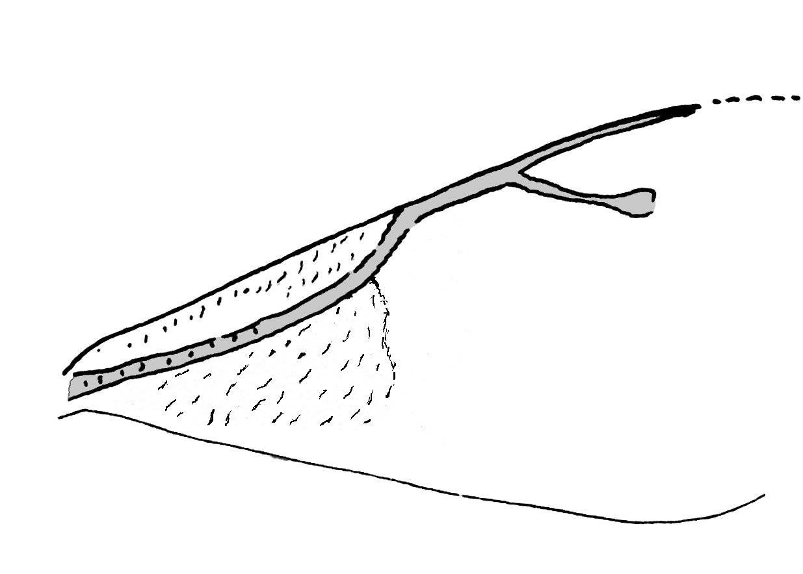
fig 14

- In both sexes, basal cell of forewing with MANY (30+) microtrichia (fig 15), on outer third or more; clypeus with CLEARLY INCISED bottom edge (fig 17);
Caenacis inflexa (Ratzeburg) 
 dark green & bronze, with gold tints; brown tapering to yellow legs; dark antennae with long conspicuous testaceous scape. b 2.8mm (2.4-4.0mm), w/b 71%, ov/b o%; 6 funicular segments (33)
 very dark green, with gold gleams; tapering brown to yellow legs; dark antennae with long, bright testaceous scape. b 2.4mm (1.8-2.7mm), w/b 78%; 6 funicular segments (9)
fig 16 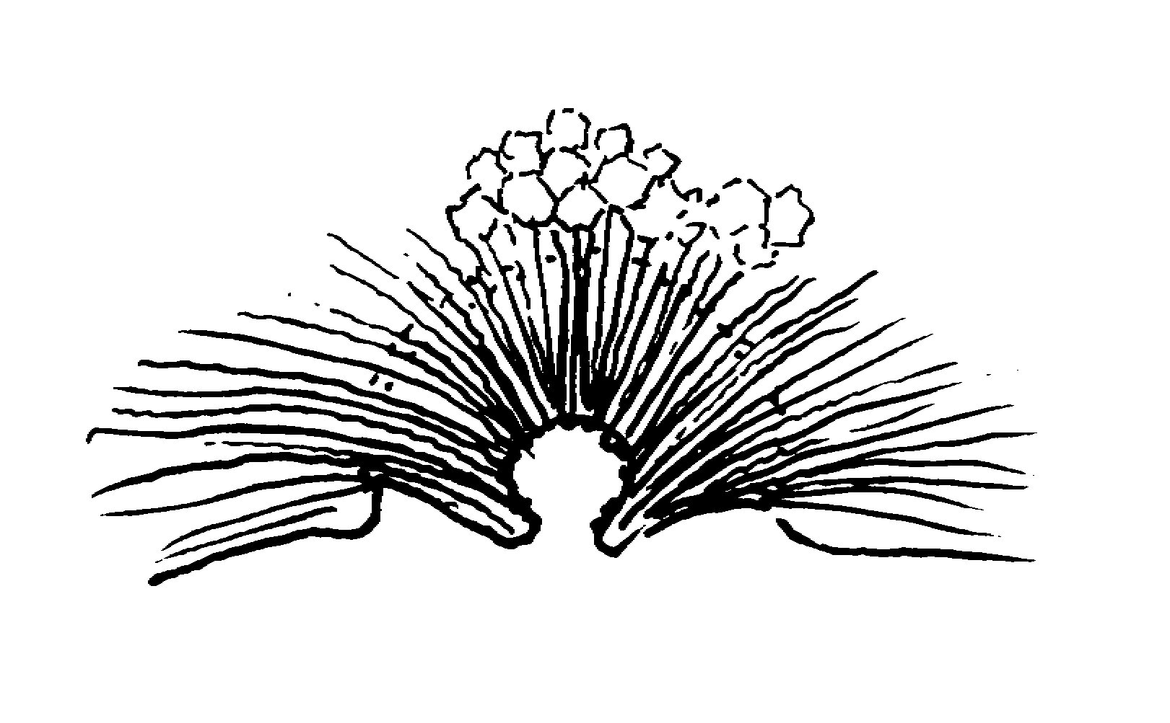fig 17
(bottom end of head, seen from front)

12.(7)  external ovipositor sheaths LONG AND SLENDER (ov/b 40%+ (fig 18)) (Torymidae); stigmal vein SHORTER than post-marginal vein (fig 19); hind coxa AT LEAST 2x length of middle coxa; 13

fig 18 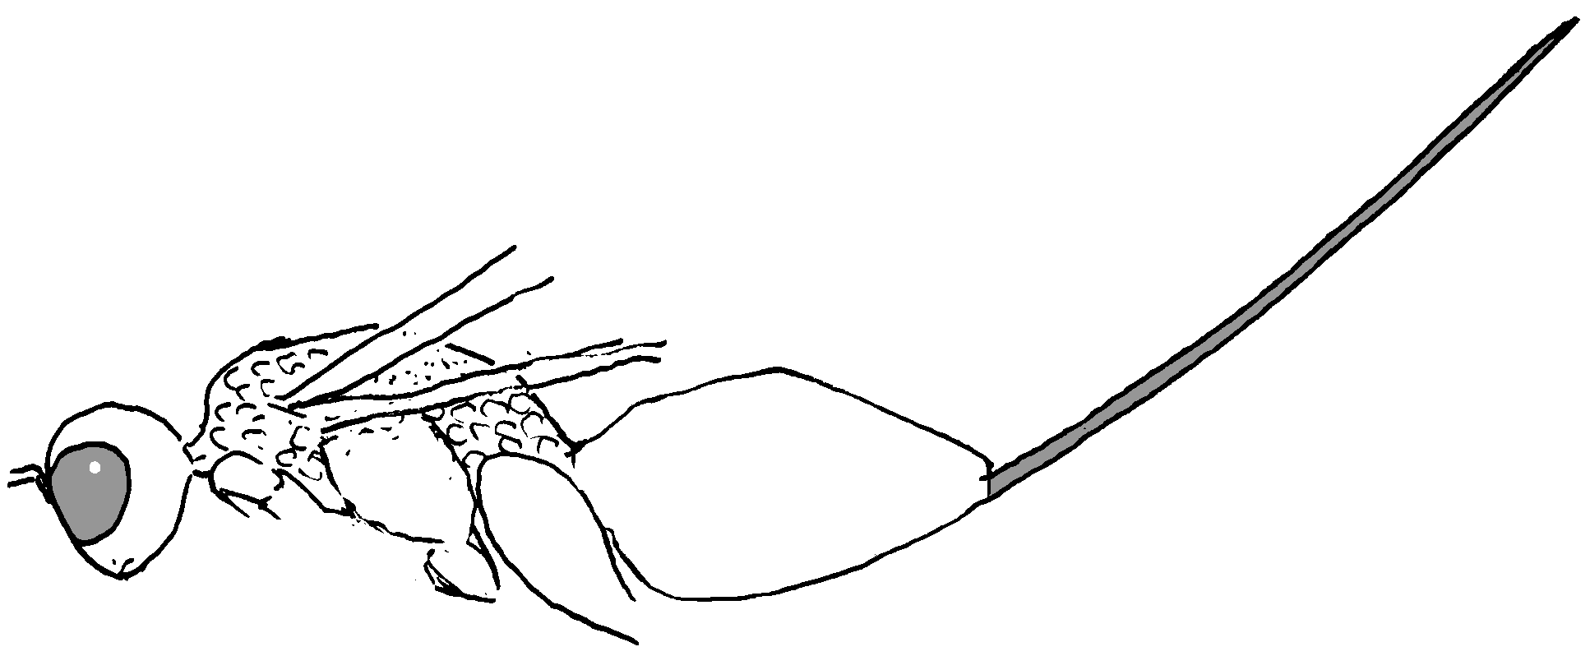 fig 19 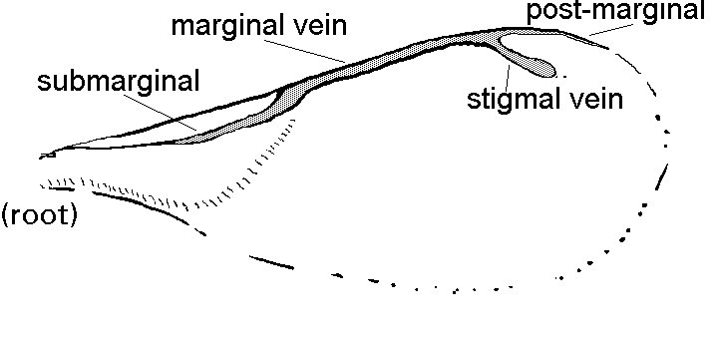
-  external ovipositor sheaths SHORT (ov/b 20%-) (Eupelmidae); stigmal vein AS LONG as post-marginal vein; hind coxa LESS THAN 1.5 X length of middle coxa, (but beware of being misled by the narrow end of the middle coxa - fig 20); 17

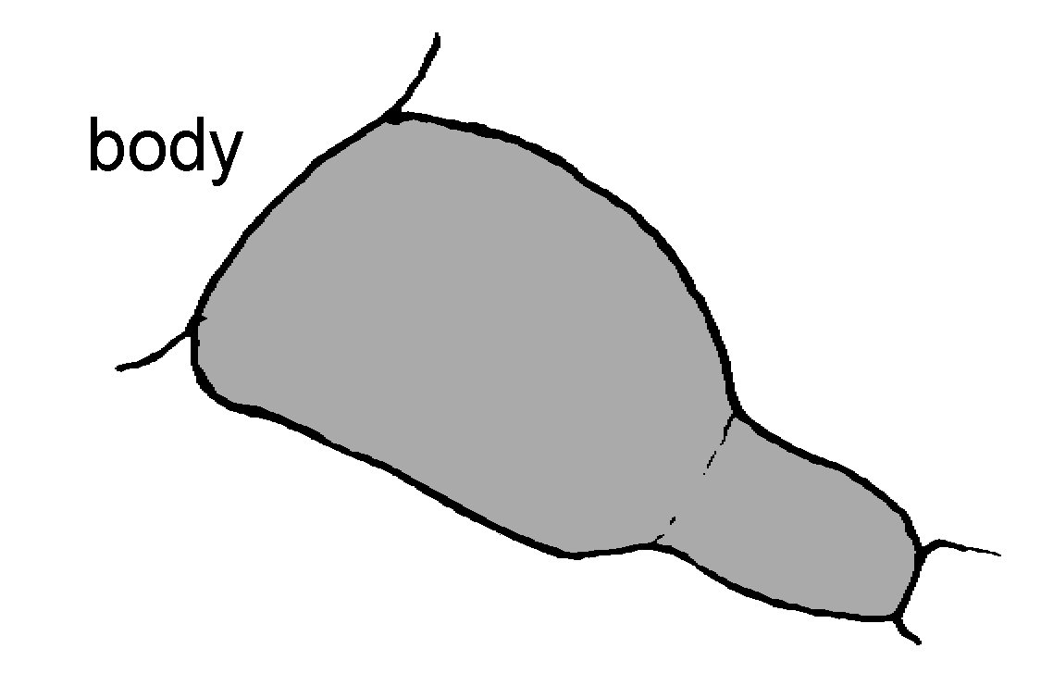fig 20

13.(12) Wings tinted BROWN all over, with LARGE dark cloud round stigma extending backwards (fig 21); body dark brown WITHOUT any metallic coloration.
Glyphomerus stigma (Fabricius) 
: semi-glossy, black to dark brown hairy body; legs and antennae dark brown; mid-length ovipositor sheaths. b. 3.4mm (1.7-4.4), w/b 80%, ov/b 68%; 7 funicular segments (20)
: semi-glossy, black to dark brown hairy body; legs & antennae dark brown. b 2.2mm (1.0-3.1), w/b, 85%; 7 funicular segments (14)
fig 21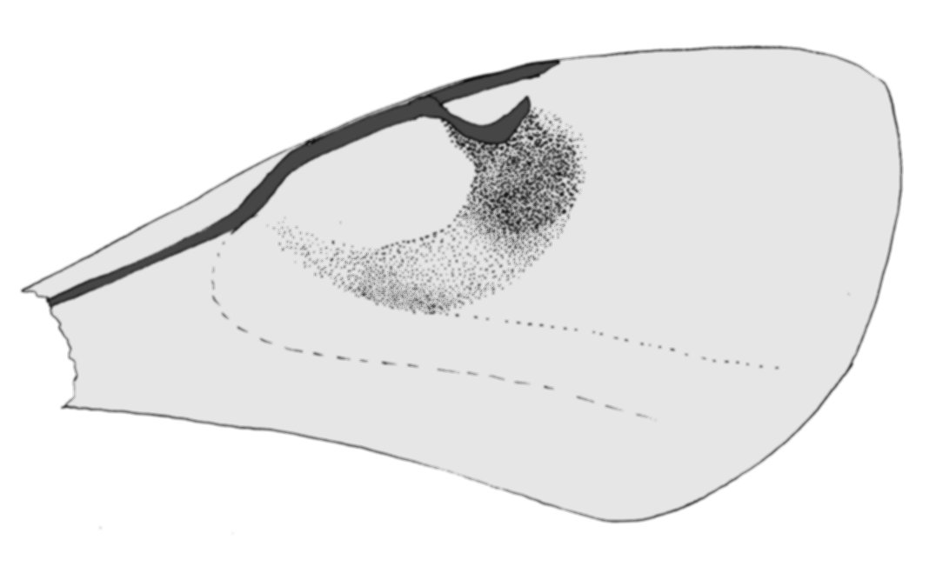
- Wings CLEAR; body METALLIC 14

14.(13) Females, with visible ovipositor sheaths 15
- Males lack ovipositor sheaths (difficult to differentiate between species) 16

15.(14) LONG ovipositor sheaths (104%); all BRONZE or GREEN metallic front coxae (in all these insects look only at the front coxa, not the trochanter below-which is quite separate and may be yellow) (fig 22); brilliant COPPERY mesepimeron (fig 23); gaster metallic green with FIERY-RED tints over at least the back.
Torymus bedeguaris (Linnaeus) 
 brilliant glossy bronze from side; above, bright metallic green, with fiery-bronze gaster; dark antennae & testaceous legs; long ovipositor sheaths. b 4.0mm (2.2-5.3mm), w/b 91%, ov/b 104%; 7 funicular segments (65).
fig 23 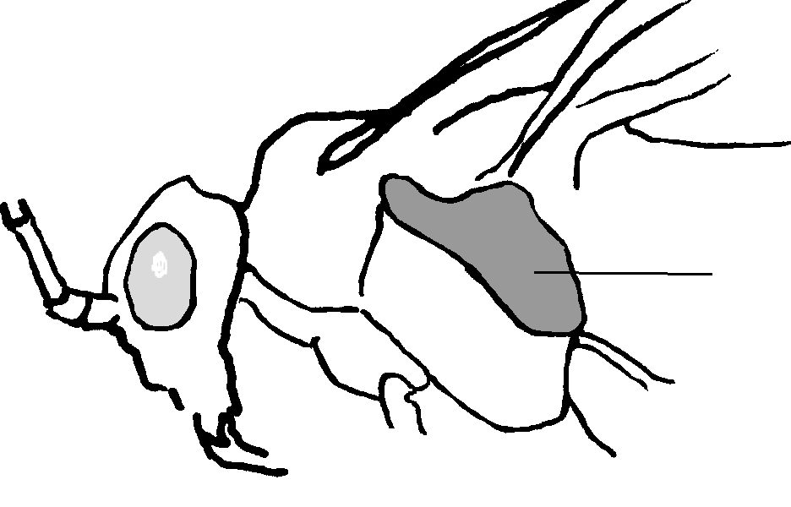 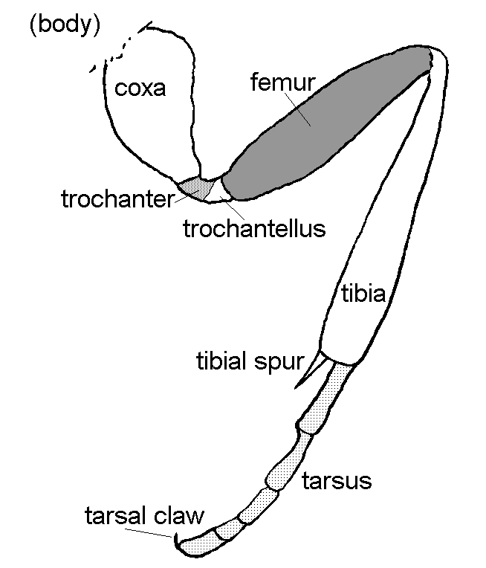fig 22
- MID-LENGTH ovipositor sheaths (70%); green coxae with at least the lowest part YELLOW; mesepimeron ALL copper; body all brilliant green-gold metallic.
Torymus rubi (Schrank) 
 brilliant metallic green body, with translucent-yellow legs & green coxae; dark brassy or black antennae; longish ovipositor sheaths. b 3.2mm (1.8-4.0mm), w/b 97%, ov/b 70%; 7 funicular segments (42)

- COMPARATIVELY SHORT ovipositor sheaths (45%); front coxae ALL metallic green; mesepimeron GREEN, with or without some bronze below; largely metallic GREEN body (this insect is extremely rare in the bedeguar gall).
Torymus microstigma (Walker)  [note 2]
 bright metallic green body with bronze tints to gaster; dark antennae; metallic & pale yellow legs. b 3.1mm (2.1-3.6), w/b 94%, ov/b 45%; 7 funicular segments (6)

16.(14) Metallic green coxae with at least the lowest part YELLOW; COPPER-coloured mesepimeron; gaster GREEN, sometimes slightly tinted with bronze at rear.
Torymus rubi (Schrank) 
 brilliant metallic green head/thorax; green gaster; translucent-yellow legs, with DARK brass-tinted antennae. b 2.3mm (1.8-2.9mm), w/b 96%; 7 funicular segments (29)
- All BRONZE or GREEN metallic front coxae; mesepimeron ALL copper; gaster brilliant metallic green & coppery RED-BRONZE.
Torymus bedeguaris (Linnaeus) 
 brilliant, glossy bronze from side; above, bright metallic green, with red-bronze & green gaster; dark antennae, with testaceous legs. b 3.0mm (1.8-4.0mm), w/b 89%; 7 funicular segments (61).

- Front coxae ALL metallic green; mesepimeron GREEN, with or without some bronze below; darker GREEN-BROWN gaster.
Torymus microstigma (Walker)  [note 2]
 dark metallic green with dark gaster; thick dark antennae; brown & pale legs. b 1.9mm, w/b 97%; 7 funicular segments (3)

17.(12) Middle tibiae virtually ALL dark; fully-winged female.
Eupelmus urozonus Dalman 
 dark metallic green; conspicuous short, banded ovipositor. b 2.7mm (1.8-3.4mm), w/b 80%, ov/b 18%; 7 funicular segments (34)
 dark metallic green, with purple coxae; dark metallic legs and dark antennae. b 1.8mm (1.3-2.5mm), w/b 78%; 7 funicular segments (22)
- Middle tibiae half YELLOW; female WINGLESS.
Eupelmus (Macroneura) vesicularis
(Retzius)  [note 3]
 b 2.8mm, w/b 0%; ov/b 13%: 7 funicular segments (1)
 dark metallic green, dark legs with pales bases; dark antennae. b 1.6mm , w/b 80%; 7 funicular segments (2)

18.(6) Post-marginal vein LONG; dark green METALLIC body.
Aulogymnus skianeuros (Ratzeburg) 
[note 4]
 Dark bronze-tinted green-gold; brown antennae, bi-coloured legs. b 2.8mm (1.5-3.5), w/b 780%, ov/b 0%; 3 funicular segments (83)
 Dark bronze-tinted green-gold; brown antennae, bi-coloured legs. b 2.1mm (1.3-3.1), w/b 84%; 4 funicular segments (84)
- Post-marginal vein SHORT (fig 24); BLACK body, + or - some yellow 19
fig 24 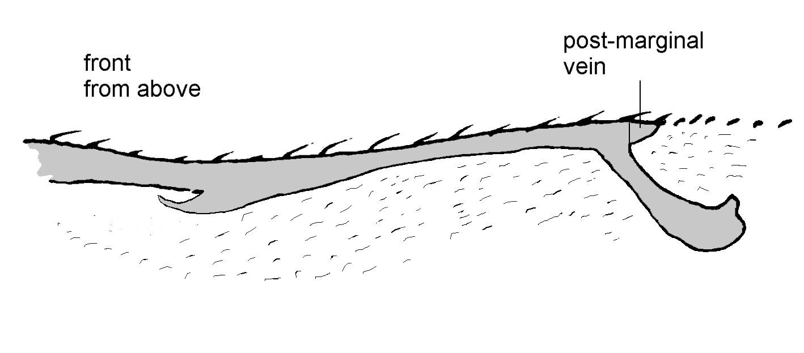

19.(18)  gaster the SAME length as head+thorax;  ventral plaque around 0.3 X length of scape (fig.25).
Aprostocetus aurantiacus (Ratzeburg)  [note 5]
 Black body, sometimes with weak bluish tinge; some yellow on top of propodeum and face; dark antennae & largely dark legs. b 1.1-1.6mm, w/b ?%, ov/b 0%; 3 funicular segments (0)
 Black body, some yellow on side and back of thorax, and on face; dark antennae & dark coxae with the rest yellow. b 1.1-1.5mm, w/b ?%; 4 funicular segments (0)
fig 25 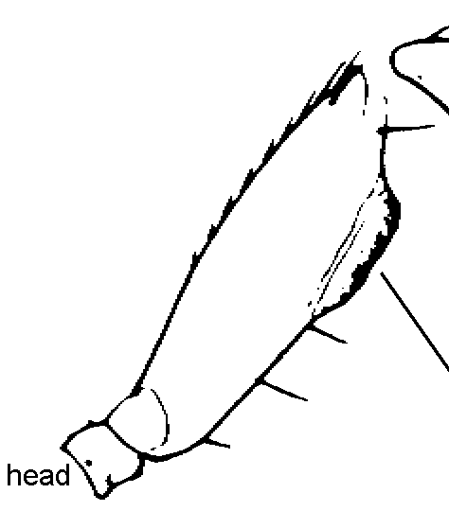ventral plaque on A. aurantiacus
(After Graham 1987)
-  gaster LONGER than head+thorax;  ventral plaque around 0.45-0.6 X length of scape [N.5].
Aprostocetus eurytomae (Nees)  [note 6]
 Black body, sometimes with yellow on side of thorax, and face; dark brassy antennae; black-banded yellow legs. b 1.6mm (0.9-1.9), w/b 81%, ov/b 12%; 3 funicular segments (10)
 Black body, sometimes with yellow on side and back of thorax, and on face; dark brassy antennae; dark coxae with rest mainly yellow. b 1.2mm (1.0-1.5), w/b 89%; 4 funicular segments (6)

It is important to emphasise that these keys cover species which may be found in Diplolepis rosae in Britain and the reasons for some of the more obscure being included are given below. Noyes (2001) gives the biology of many chalcid species and these show some with records for Diplolepis rosae in Europe which have not yet apparently been found in this country. So it is possible the list will increase further, beyond the present seventeen species.
NOTES:
[note 1] Mesopolobus fasciiventris (Forster) – believed first in Europe; (Robin Williams, from a gall found by Toddy Cooper in Beer, Devon in 2005).
[note 2] Torymus microstigma (Walker) - first in Europe; (Robin Williams, from a gall found by Toddy Cooper in Beer, Devon in 2005), followed by another in Somerset, near Taunton, in 2006.
[note 3] Eupelmus vesicularis (Retzius) - Dr Askew originally saw this record as doubtful, but a male has been reared since from Diplolepis spinosissimae (Philip Entwistle/Robin Williams), which may make this more likely.
[note 4] Aulogymnus skianeuros (Ratzeburg) – a 1999 record in Cheddar Woods, Somerset, (Robin Williams) of two males reared from a bedeguar, was the first for this gall in this country. A second bedeguar record, of a single female, from Minehead in Somerset, (Robin Williams) has since been confirmed. The only previous record for Europe was a single rearing of two males in Germany in 1979. Aulogymnus skianeuros is a common parasitoid in Oak apples.
[note 5] Aprostocetus pygmaeus (= conon) (Zetterstedt) has been bred from a gall in Britain but Dr Askew felt it was almost certainly not an original gall inhabitant, as it is normally associated with grasses, and is therefore probably a misidentification. Aprostocetus aurantiacus (Ratzeburg) is found in the other four of the five Diplolepis rose-galls and is more likely as a sound bedeguar species.
[note 6] Aprostocetus eurytomae (Nees) was new to Britain, (Askew 1997), when it was found in Smooth pea galls. Jennings (2003), who bred further specimens from Smooth pea galls, suggests that its history indicates it may be found in any Diplolepis gall; hence its inclusion in these keys. This is further strengthened by two records for this insect from Rose bedeguar in southern France (Graham 1996).
IMPORTANT: anyone suspecting either Aprostocetus aurantiacus or A. eurytomae ought to contact us about obtaining formal identification by an expert. Males, in particular, are virtually identical and really require a number of difficult measurements to separate them.
REFERENCES:
R.R. Askew; (Aprostocetus eurytomae new to Britain 1n 1993 & 1994 from galls of Diplolepis spinosissimae in Yorkshire), Entomologists’ Monthly Magazine 133: 177, 1997.
R.D. Eady & J. Quinlan; HYMENOPTERA CYNIPOIDEA: A KEY TO FAMILIES & SUBFAMILIES & CYNIPINAE (INCLUDING GALLS). Handbooks for the Identification of British Insects Vol. V111. Part 1 (a), RES; 1963
M.W.R. de V. Graham & M.J. Gijwijt; REVISION OF THE EUROPEAN SPECIES OF TORYMUS Dalman (s. lat.) (HYMENOPTERA: TORYMIDAE). Zoologische Verhandelingen 317, Leiden; 1998.
M.W.R. de V. Graham; A RECLASSIFICATION OF THE EUROPEAN TETRASTICHINAE (HYMENOPTERA: EULOPHIDAE) WITH A REVISION OF CERTAIN GENERA. Bulletin of the British Museum (Natural History) Entomology series, Vol. 55(1), 1987.
M.W.R. de V. Graham; THE PTEROMALIDAE OF NORTH-WESTERN EUROPE (HYMENOPTERA: CHALCIDOIDEA). Bulletin of the British Museum (Natural History) Entomology, Supplement 16, 1969.
M.W.R. de V. Graham; ENTOMOLOGICAL NOTES ON LA CRAU (FRANCE: BOUCHES DU RHÔNE): Entomologists’Monthly Magazine 132: 197-203, 1996.
M.T. Jennings; A RECORD OF APROSTOCETUS EURYTOMAE (NEES 1834) (HYM. EULOPHIDAE) FROM KENT. Entomologist’s Monthly Magazine; 1673-75, 2003.
John S. Noyes; INTERACTIVE CATALOGUE OF WORLD CHALCIDOIDEA 2001; SCIENTIFIC NAMES FOR INFORMATION MANAGEMENT (on CD). Taxapad, The Natural History Museum (2001)
Some obvious differences between male () and female () chalcids (basic shapes/structure)

Eulophidae (Aprostocetus, Aulogymnus)
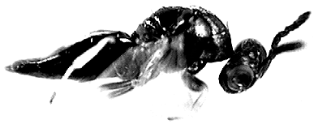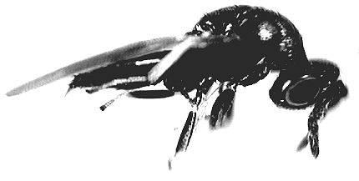

Eupelmus urozonus
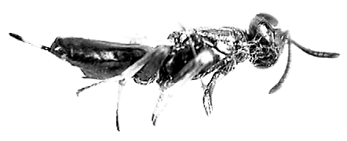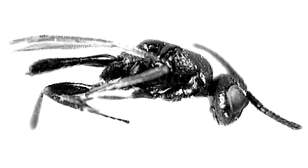

Eurytoma rosae
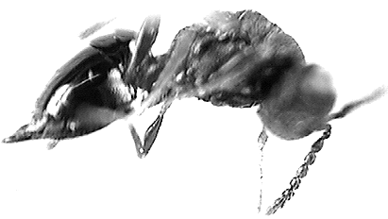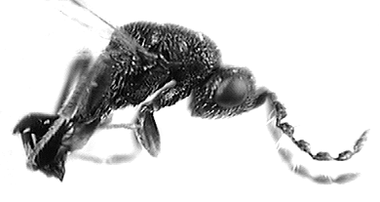

Pteromalidae (Caenacis, Mesopolobus, Pteromalus)
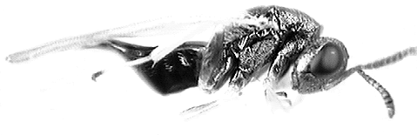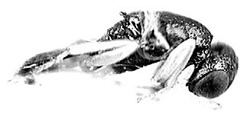

Torymidae (Glyphomerus, Torymus)

 

